SIMATS ENGINEERING (SAVEETHA SCHOOL OF ENGINEERING)
Department of Computer Science and Engineering

ASSESSMENT TOOL 1– Concept Mapping

Course Code: | CSA0312 | Course Title: | Data Structures
CO Assessed: | CO1 – Imitation (BL3, BL4) | Assessment: | Assessment Tool 1 – Concept Mapping
Weightage: | 10% of CIA | Total Marks: | 100
CO1 Statement: | Basics, Data, Data object, Data structure, Abstract Data Types (ADT), realization of ADT in ‘C’, Primitive and non-primitive data structure, Linear and non-linear data structure Arrays & Recursion, Performance analysis and Measurement: Time and space analysis of algorithms, Average, best and worst-case analysis.
Student Name: | Brasilla R | Reg. No.: | 192511357
Section / Batch: | B TECH CSE | Date: | 22-07-2026
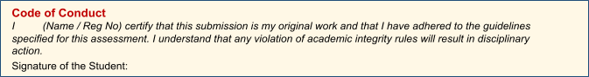
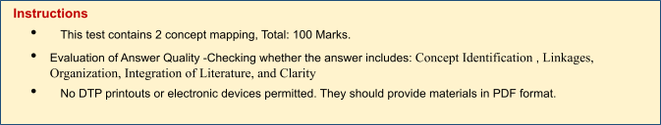

Annexure A – Concept Mapping

QUESTION:

A file system contains nested folders and files organized hierarchically. Construct a concept map
linking Recursion → Base Case → Recursive Case → Call Stack → Function Calls → Memory Usage.
Analyze how recursion operates internally and explain the relationship between recursive calls and stack
memory. Justify why recursion is suitable for solving hierarchical problems.

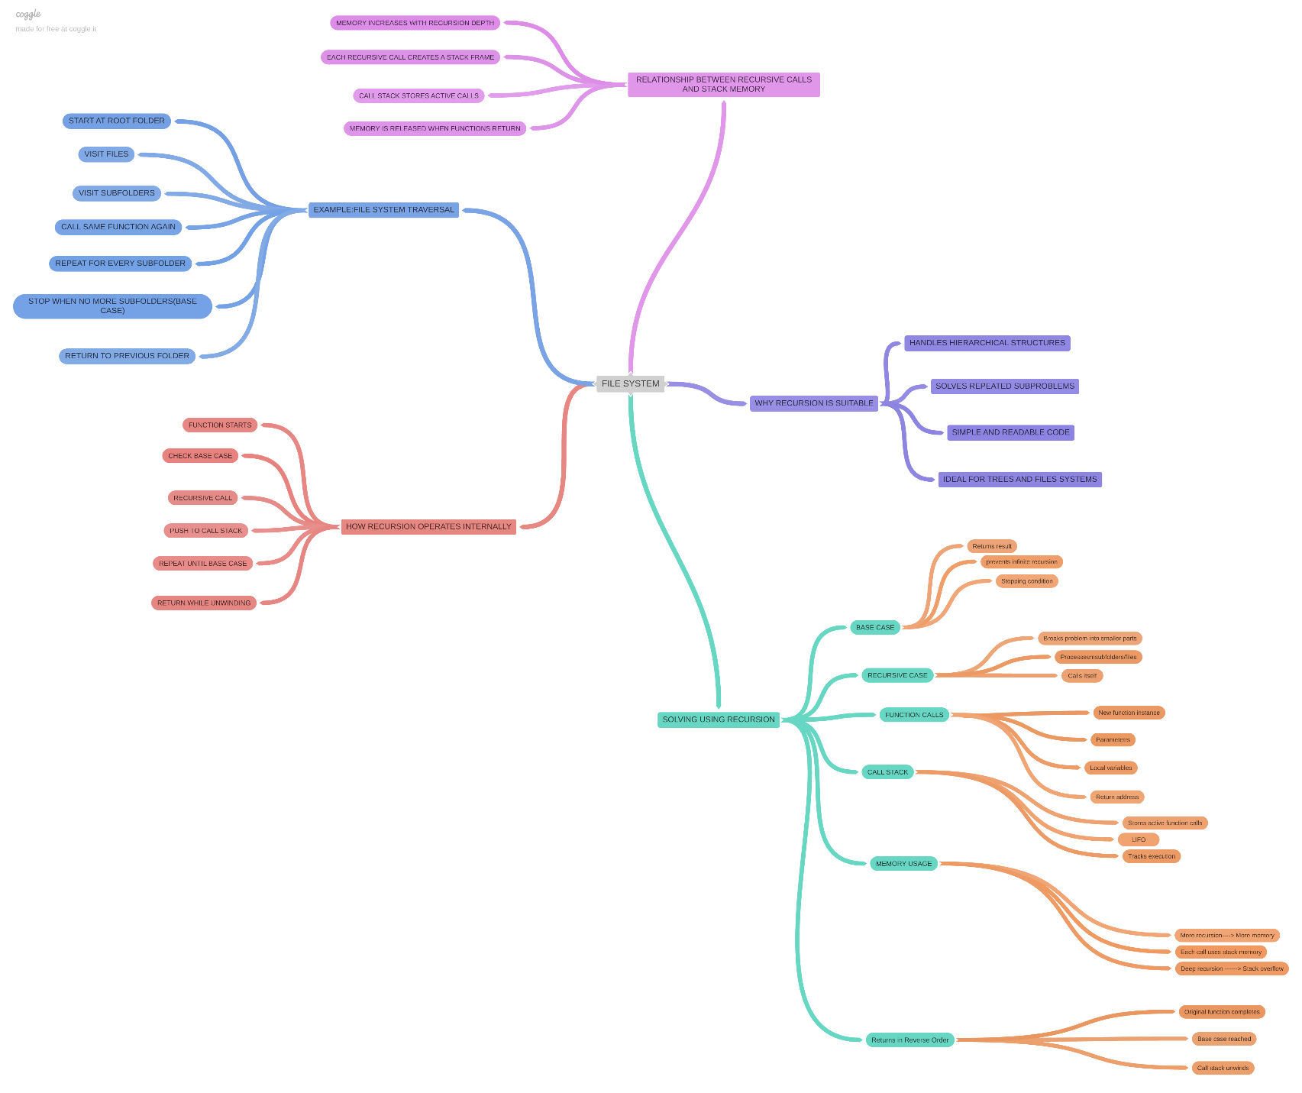

Rubrics

Questions | Problem Understandin g | Method Selection | Solutio n Process | Accuracy of Calculation | Interpretation of Results | Total Marks
Q1
Q2

